Artificial Intelligence

Assignment # 05

Name: Ahmed Kasteer

Roll Number: 20F-0336

Section: 6C

Question 1:

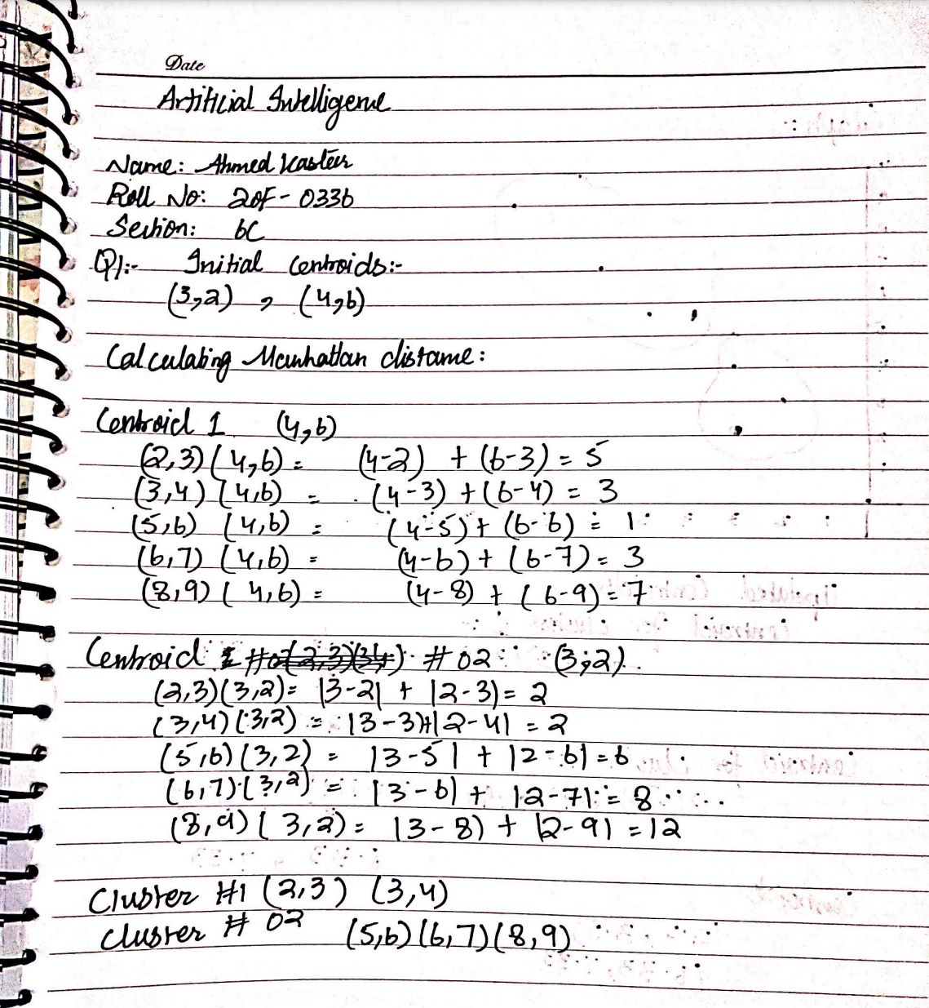

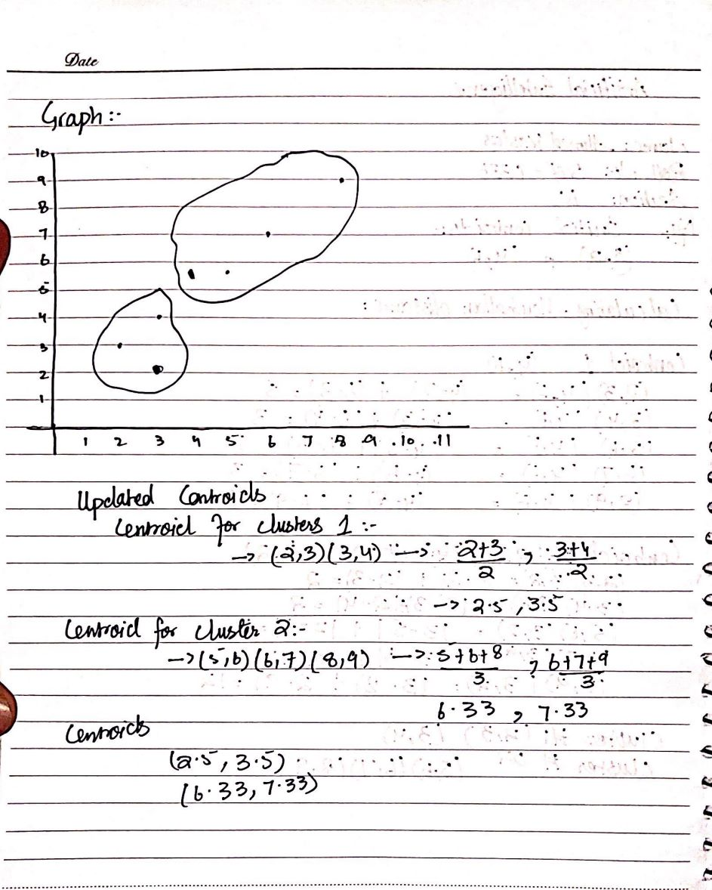

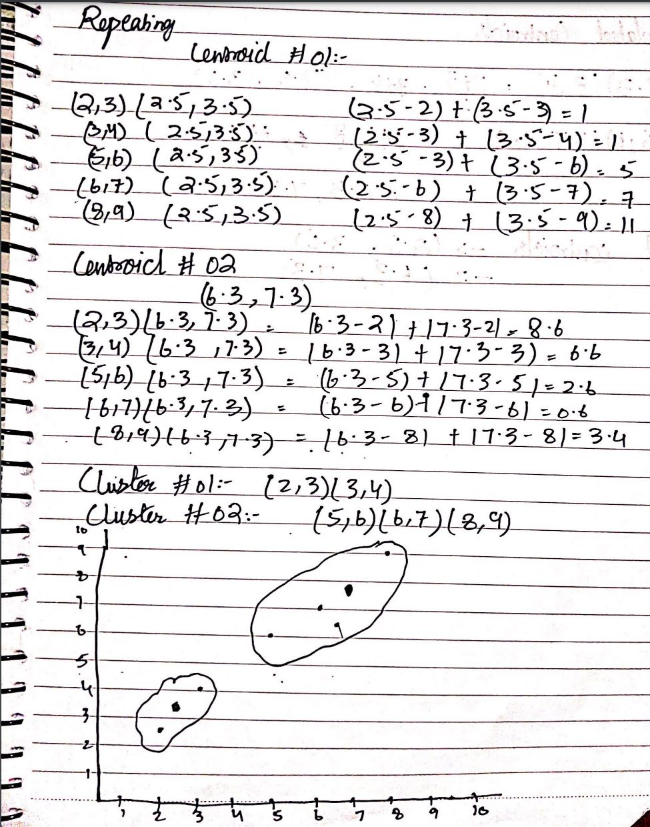

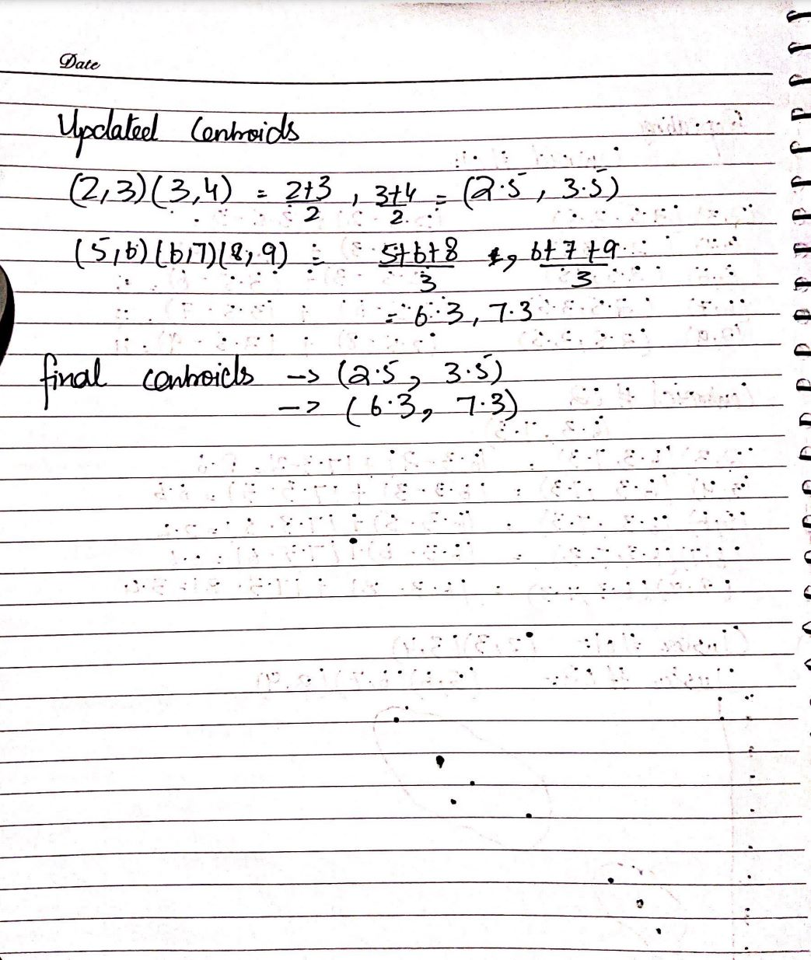

Question No: 2

import pandas as pd  
import random  
import math  
import matplotlib.pyplot as plt  
  
data = pd.read_csv(r'C:\\Users\\ahmed\\PycharmProjects\\pythonProject20\\data.csv')  
x = pd.DataFrame(data, columns=['X'])  
y = pd.DataFrame(data, columns=['Y'])  
  
x_axis = []  
y_axis = []  
for i in range(50):  
 x_axis.append(x['X'][i])  
 y_axis.append(y['Y'][i])  
  
centroid_1 = (random.choice(x_axis), random.choice(y_axis))  
centroid_2 = (random.choice(x_axis), random.choice(y_axis))  
  
pre_1 = None  
pre_2 = None  
cluster1_x = []  
cluster1_y = []  
cluster2_y = []  
cluster2_x = []  
  
while pre_1 != centroid_1 or pre_2 != centroid_2:  
 cluster1_x.clear()  
 cluster1_y.clear()  
 cluster2_x.clear()  
 cluster2_y.clear()  
  
 for i, j in zip(x_axis, y_axis):  
 test = (i, j)  
 if math.dist(test, centroid_1) < math.dist(test, centroid_2):  
 cluster1_x.append(i)  
 cluster1_y.append(j)  
 else:  
 cluster2_x.append(i)  
 cluster2_y.append(j)  
  
 pre_1 = centroid_1  
 pre_2 = centroid_2  
  
 centroid_1 = (sum(cluster1_x) / len(cluster1_x), sum(cluster1_y) / len(cluster1_y))  
 centroid_2 = (sum(cluster2_x) / len(cluster2_x), sum(cluster2_y) / len(cluster2_y))  
  
plt.scatter(cluster1_x, cluster1_y, c='red', label='Cluster 1')  
plt.scatter(cluster2_x, cluster2_y, c='blue', label='Cluster 2')  
plt.xlabel('X')  
plt.ylabel('Y')  
plt.show()

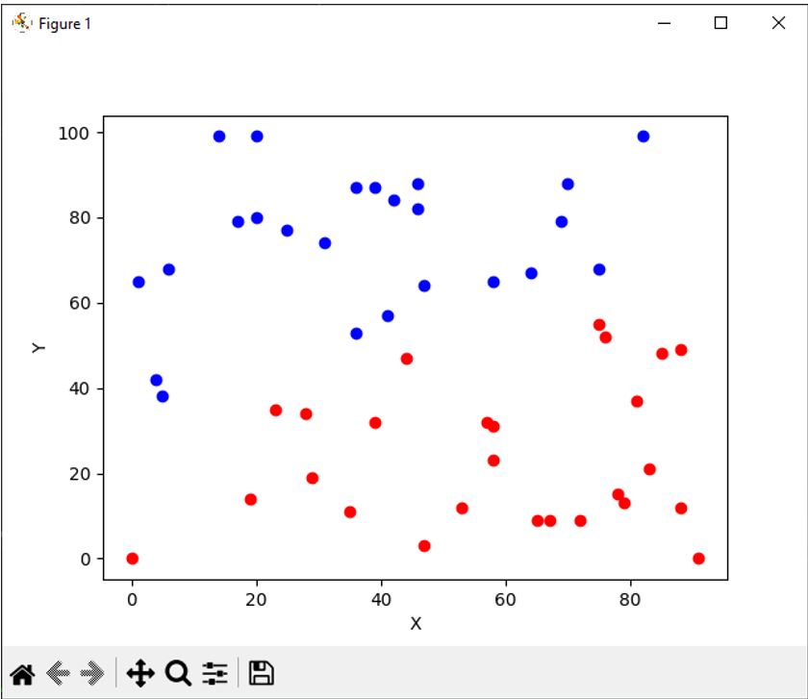

Question 3:

import pandas as pd  
import random  
import math  
import matplotlib.pyplot as plt  
  
data = pd.read_csv(r'C:\\Users\\ahmed\\PycharmProjects\\pythonProject20\\data.csv')  
x = pd.DataFrame(data, columns=['X'])  
y = pd.DataFrame(data, columns=['Y'])  
  
x_axis = []  
y_axis = []  
for i in range(50):  
 x_axis.append(x['X'][i])  
 y_axis.append(y['Y'][i])  
  
k_values = range(1, 10)  
wcss = []  
  
for k in k_values:  
 centroid_1 = (random.choice(x_axis), random.choice(y_axis))  
 centroid_2 = (random.choice(x_axis), random.choice(y_axis))  
  
 pre_1 = None  
 pre_2 = None  
 cluster1_x = []  
 cluster1_y = []  
 cluster2_y = []  
 cluster2_x = []  
  
 while pre_1 != centroid_1 or pre_2 != centroid_2:  
 cluster1_x.clear()  
 cluster1_y.clear()  
 cluster2_x.clear()  
 cluster2_y.clear()  
  
 for i, j in zip(x_axis, y_axis):  
 test = (i, j)  
 if math.dist(test, centroid_1) < math.dist(test, centroid_2):  
 cluster1_x.append(i)  
 cluster1_y.append(j)  
 else:  
 cluster2_x.append(i)  
 cluster2_y.append(j)  
  
 pre_1 = centroid_1  
 pre_2 = centroid_2  
  
 centroid_1 = (sum(cluster1_x) / len(cluster1_x), sum(cluster1_y) / len(cluster1_y))  
 centroid_2 = (sum(cluster2_x) / len(cluster2_x), sum(cluster2_y) / len(cluster2_y))  
  
 wcss.append(sum(math.dist((i, j), centroid_1)**2 for i, j in zip(cluster1_x, cluster1_y)) +  
 sum(math.dist((i, j), centroid_2)**2 for i, j in zip(cluster2_x, cluster2_y)))  
  
plt.plot(k_values, wcss, marker='o', linestyle='-', color='b')  
plt.xlabel('Number of Clusters (k)')  
plt.ylabel('Within-Cluster Sum of Squares (WCSS)')  
plt.title('Elbow Curve')  
plt.show()

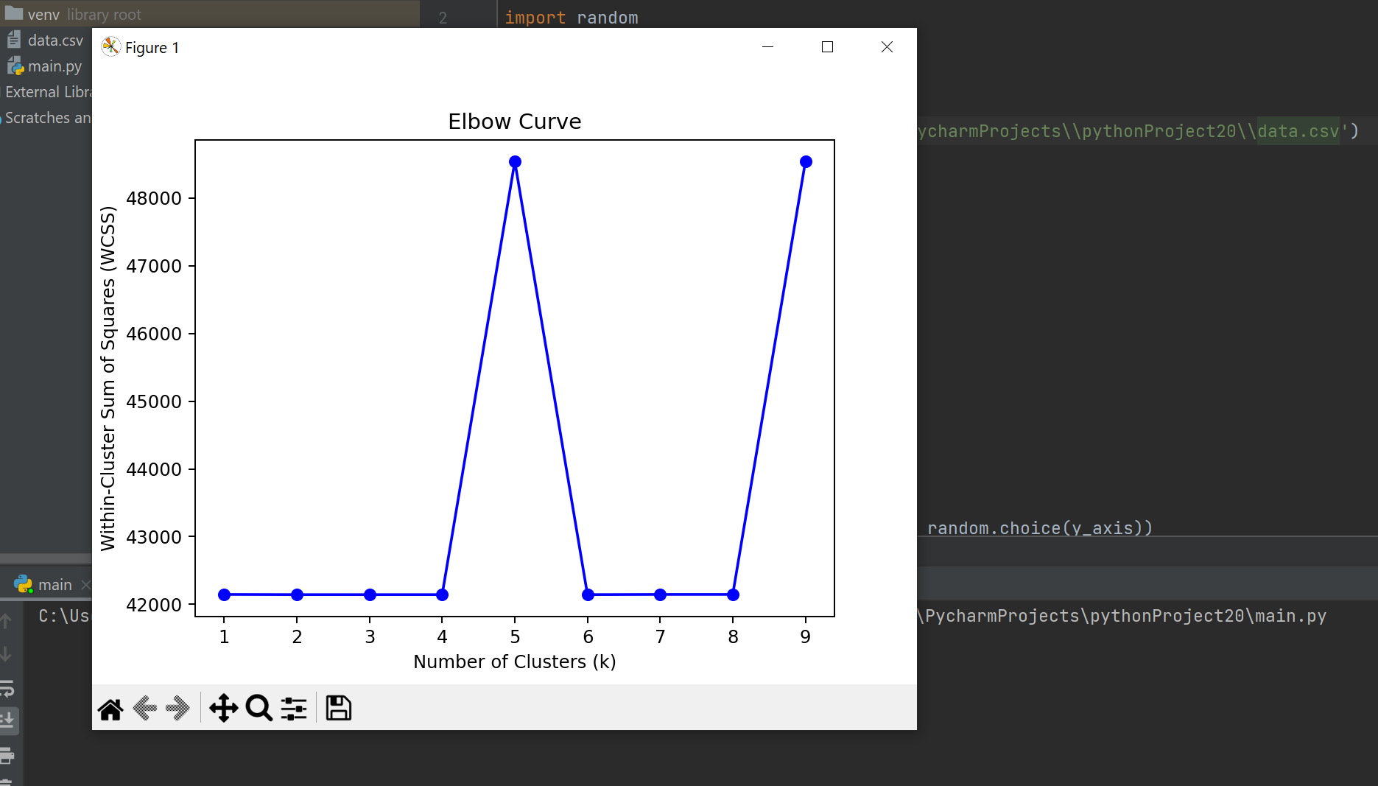

Question: 4

import pandas as pd  
import random  
import math  
import matplotlib.pyplot as plt  
  
data = pd.read_csv(r'C:\\Users\\ahmed\\PycharmProjects\\pythonProject20\\data.csv')  
x = pd.DataFrame(data, columns=['X'])  
y = pd.DataFrame(data, columns=['Y'])  
  
x_axis = []  
y_axis = []  
for i in range(50):  
 x_axis.append(x['X'][i])  
 y_axis.append(y['Y'][i])  
  
centroid_1 = (random.choice(x_axis), random.choice(y_axis))  
centroid_2 = (random.choice(x_axis), random.choice(y_axis))  
centroid_3 = (random.choice(x_axis), random.choice(y_axis))  
  
pre_1 = None  
pre_2 = None  
pre_3 = None  
  
cluster1_x = []  
cluster1_y = []  
cluster2_x = []  
cluster2_y = []  
cluster3_x = []  
cluster3_y = []  
  
while pre_1 != centroid_1 or pre_2 != centroid_2 or pre_3 != centroid_3:  
 cluster1_x.clear()  
 cluster1_y.clear()  
 cluster2_x.clear()  
 cluster2_y.clear()  
 cluster3_x.clear()  
 cluster3_y.clear()  
  
 for i, j in zip(x_axis, y_axis):  
 test = (i, j)  
 distances = [  
 math.dist(test, centroid_1),  
 math.dist(test, centroid_2),  
 math.dist(test, centroid_3)  
 ]  
 min_distance = min(distances)  
  
 if min_distance == distances[0]:  
 cluster1_x.append(i)  
 cluster1_y.append(j)  
 elif min_distance == distances[1]:  
 cluster2_x.append(i)  
 cluster2_y.append(j)  
 else:  
 cluster3_x.append(i)  
 cluster3_y.append(j)  
  
 pre_1 = centroid_1  
 pre_2 = centroid_2  
 pre_3 = centroid_3  
  
 centroid_1 = (sum(cluster1_x) / len(cluster1_x), sum(cluster1_y) / len(cluster1_y))  
 centroid_2 = (sum(cluster2_x) / len(cluster2_x), sum(cluster2_y) / len(cluster2_y))  
 centroid_3 = (sum(cluster3_x) / len(cluster3_x), sum(cluster3_y) / len(cluster3_y))  
  
plt.scatter(cluster1_x, cluster1_y, c='red', label='Cluster 1')  
plt.scatter(cluster2_x, cluster2_y, c='blue', label='Cluster 2')  
plt.scatter(cluster3_x, cluster3_y, c='yellow', label='Cluster 3')  
plt.xlabel('X')  
plt.ylabel('Y')  
plt.legend()  
plt.show()

